**HERBIVORY ON INDIVIDUAL HOSTS AT MUSH**

**1. Linear model results**

We first tested the strength of individual predictor variables in determining damage frequency and diversity on a single host plant. Results are as follows:

|  |  |  |  |  |
| --- | --- | --- | --- | --- |
|  | % Damage | % Specialized Damage | Total DTs at 20 leaves | Specialized DTs at 20 leaves |
| Leaf Mass per Area | F-statistic: 1.63  Multiple R2: 0.13  p: 0.23 | F-statistic: 0.44  Multiple R2: 0.04  p: 0.52 | F-statistic: 1.41  Multiple R2: 0.12  p: 0.26 | F-statistic: 0.92  Multiple R2: 0.08  p: 0.36 |
| Presence/Absence of Trichomes | F-statistic: 1.19  Multiple R2: 0.09  p: 0.30 | F-statistic: <.01  Multiple R2: <.01  p: 0.96 | F-statistic: 1.26  Multiple R2: 0.10  p: 0.28 | F-statistic: 0.06  Multiple R2: <.01  p: 0.81 |
| Potential for N-fixing symbionts (Legume or not legume) | F-statistic: 0.87  Multiple R2: 0.07  p: 0.37 | F-statistic: 1.62  Multiple R2: 0.12  p: 0.23 | F-statistic: 0.29  Multiple R2: 0.02  p: 0.59 | F-statistic: 0.54  Multiple R2: 0.04  p: 0.47 |
| Proportional abundance at Mush | F-statistic: 0.56  Multiple R2: 0.04  p: 0.47 | F-statistic: 0.16  Multiple R2: 0.01  p: 0.69 | F-statistic: 0.18  Multiple R2: 0.01  p: 0.68 | F-statistic: 0.15  Multiple R2: 0.01  p: 0.70 |

After running models with a single predictor variable, we then ran models with multiple predictor variables, iteratively adding variables ordered based on size of the F- and multiple R2 values. Results are as follows:

**Damage Frequency**

Model 1: Leaf Mass per Area + Trichomes

F-statistic: 1.20

Multiple R2: 0.20

p: 0.34

Model 2: Leaf Mass per Area + Trichomes + N-fixing

F-statistic: 1.66

Multiple R2: 0.36

p: 0.24

Model 3: Leaf Mass per Area + Trichomes + N-fixing + Proportional Abundance

F-statistic: 1.18

Multiple R2: 0.37

p: 0.38

Conclusion: No combination of predictor variables has a significant effect on damage frequency. Leaf mass per area and potential for N-fixing symbionts have larger effects than presence/absence of trichomes or proportional abundance in the flora.

**Specialized Damage Frequency**

Model 1: N-fixing + Leaf Mass per Area

F-statistic: 1.35

Multiple R2: 0.23

p: 0.30

Model 2: N-fixing + Leaf Mass per Area + Trichomes

F-statistic: 1.00

Multiple R2: 0.27

p: 0.44

Model 3: N-fixing + Leaf Mass per Area + Trichomes + Proportional Abundance

F-statistic: 0.68

Multiple R2: 0.28

p: 0.62

Conclusion: No combination of predictor variables has a significant effect on specialized damage frequency. Potential for N-fixing symbionts and leaf mass per area have larger effects than presence/absence of trichomes or proportional abundance in the flora.

**Damage Diversity**

Model 1: Leaf mass per area + Trichomes

F-statistic: 1.15

Multiple R2: 0.19

p: 0.36

Model 2: Leaf mass per area + Trichomes + N-fixing

F-statistic: 1.11

Multiple R2: 0.27

p: 0.40

Model 3: Leaf mass per area + Trichomes + N-fixing + Proportional Abundance

F-statistic: 0.76

Multiple R2: 0.28

p: 0.58

Conclusion: While leaf mass per area and potential for N-fixing symbionts have the largest effect of the four predictors, none explains much variance in the dataset or has a significant relationship.

**Specialized Damage Diversity**

Model 1: Leaf mass per area + N-fixing

F-statistic: 1.10

Multiple R2: 0.18

p: 0.37

Model 2: Leaf mass per area + N-fixing + Trichomes

F-statistic: 1.10

Multiple R2: 0.27

p: 0.40

Model 3: Leaf mass per area + N-fixing + Trichomes + Proportional Abundance

F-statistic: 0.76

Multiple R2: 0.28

p: 0.58

Conclusion: No combination of predictor variables has a significant effect on specialized damage diversity.

**2. Welch two sample t-test results**

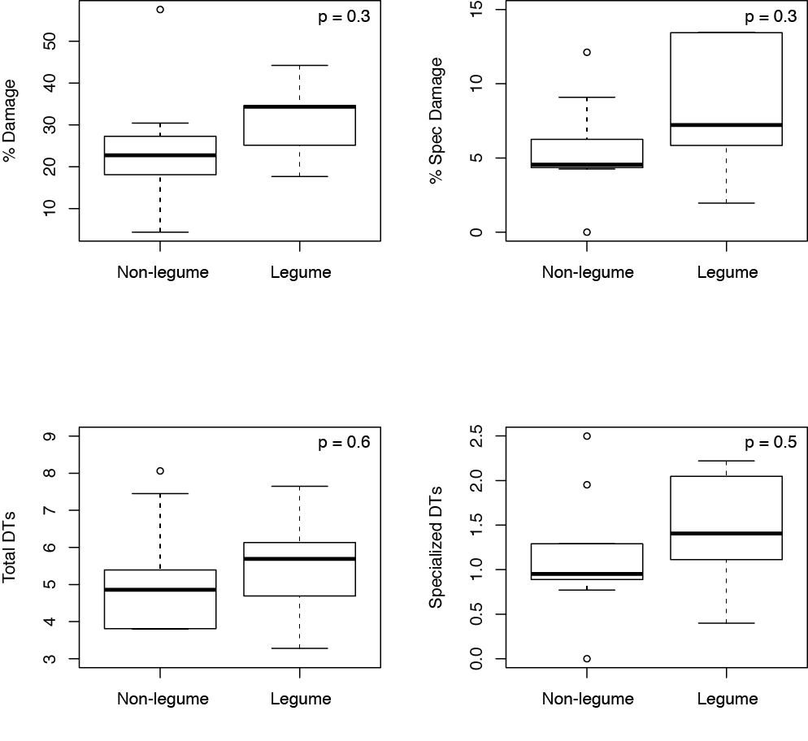

Boxplots of herbivory on legumes (n = 5) vs. non-legumes (n = 9). No significant differences were observed.

_____________________________________________________________________________________

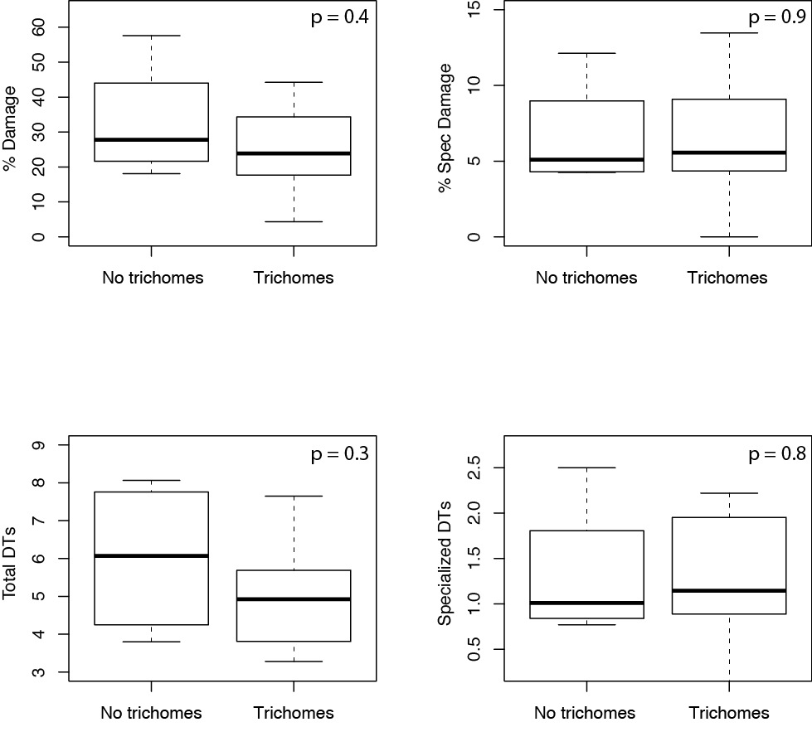

Boxplots of herbivory on taxa with (n = 10) and without trichomes (n = 4). No significant differences were observed.